Megan Dominy
202-429-4785
Actors@capitaltalentagency.com
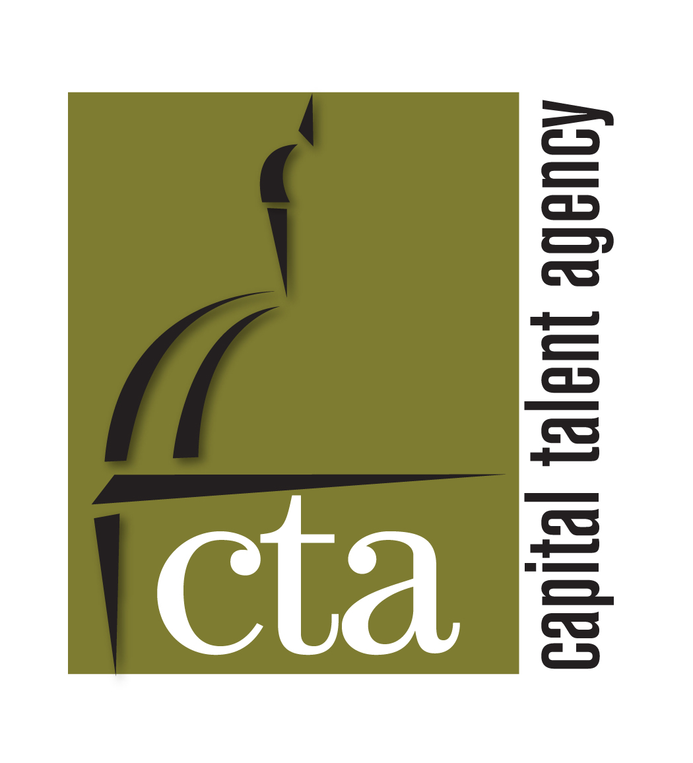

EMC

Theater

Journey to the West (Current) | Suhbodi, et al | Constellation Theatre/ Dir. Allison Stockman
Othello | Desdemona U/S | Shakespeare Theatre Company/ Dir. Ron Daniels
The Cripple of Inishmaan | Helen | Scena Theatre/ Dir. Robert McNamara
The Wedding Party | Caitlin | 10th Muse Productions/ Dir. Abbie Isaac Fine
On Approval | Helen | Washington Stage Guild/ Dir. Steven Carpenter
The Lieutenant of Inishmore | Mairead | Constellation Theatre/Dir. Matt Wilson
Tiny Tim’s Christmas Carol | Puppetseller | Adventure Theatre MTC/Dir. Jerry Whiddon
Lolita, Reinterpreted | Lolita | Mead Theatre Lab/Dir. Rachel Hynes
A Midsummer Night’s Dream | Titania/Hippolyta | Prince George’s County Shakespeare/Dir. Christopher Dwyer
Love of the Nightingale | Philomele | Constellation Theatre/Dir. Allison Stockman
Scapin | Hyacinth | Constellation Theatre/Dir. Kate Bryer
36 Views | Elizabeth | Constellation Theatre/Dir. Allison Stockman
Caesar and Dada | Anna | WSC Avant Bard/Dir. Lee Mikeska
From Here to There | Megan | Imagination Stage/Dir. Natasha Holmes
Two Gentlemen of Verona | Julia | Chesapeake Shakespeare Company/Dir. Patrick Kilpatrick
Hemispheric Dysfunctionalism… | Pursimone | 5th Dentist/Dirs. Michael Merino & Kerri Rambow
A Maze | Kim/Tisch | Rorschach Theatre/Dir. Grady Weatherford
Metamorphoses | Myrrha/Others | Constellation Theatre/Dir. Allison Stockman
Wake Up, Brother Bear | Sister Bear | Imagination Stage/ Dir. Kate Bryer
The Ramayana | Soorpanaka/Others | Constellation Theatre/Dir. Allison Stockman
Almost, Maine | Gayle/Others | 1st Stage/Dir. Michael Chamberlin
The Taming of the Shrew | Katherine | Maryland Shakespeare Festival/Dir. John Bellomo
Twelfth Night | Olivia | Maryland Shakespeare Festival/Dir. Becky Kemper
Tamberlaine | 2nd Virgin | Shakespeare Theatre Company/Dir. Michael Kahn
Edward III | Swing | Shakespeare Theatre Company/Dir. Gale Edwards
The Other Room | Lily | Kennedy Center-VSA Arts/Dir. PD Michnewicz
A Midsummer Night’s Dream | Peaseblossom, Hermia u/s (per.) | Folger Theatre/Dir. Joe Banno
Private Lives | Sybil | Washington Shakespeare Company/Dir. H. Lee Gable
Barefoot in the Park | Corie | Bay Theatre Company/Dir. Peter Wray

Film/ Television

Spooky Fast- Volkswagen Commercial | Lead | ISL
Everyday Hero (Training Film) | Supporting | Metro Productions
What About Will | Lead | Curisity Entertainment
The Stone and the Sunflower | Lead | Junesong Arts
This is the Truth | Supporting | Junesong Arts
Deadly Affairs | Lindsay | Sirens Media
America’s Most Wanted | Lead | 20th Century Fox
Oklahoma City Community College | Lead | Blue Diamond Productions
Taco Mayo Commercial | Lead | Evergreen Productions, Inc.

Training/Special Skills
MFA, Catholic University of America Shakespeare & Company Summer Training Institute
BFA, University of Oklahoma Movement/ Clown (Paata Tsikurishvili & Dody DiSanto)
Penny Templeton Studio (New York City)
SPECIAL SKILLS
Certified Zumba instructor, Stage combat-rapier/dagger, Dialects, Basic juggling, Cartwheels, Backbend, Valid driver’s license, Valid passport

